Room Location Information and Acronyms
Trinity Chapel: A small chapel off to the side of the main church. When you walk in the front doors, veer slightly left and you'll see it labeled above the double doors.
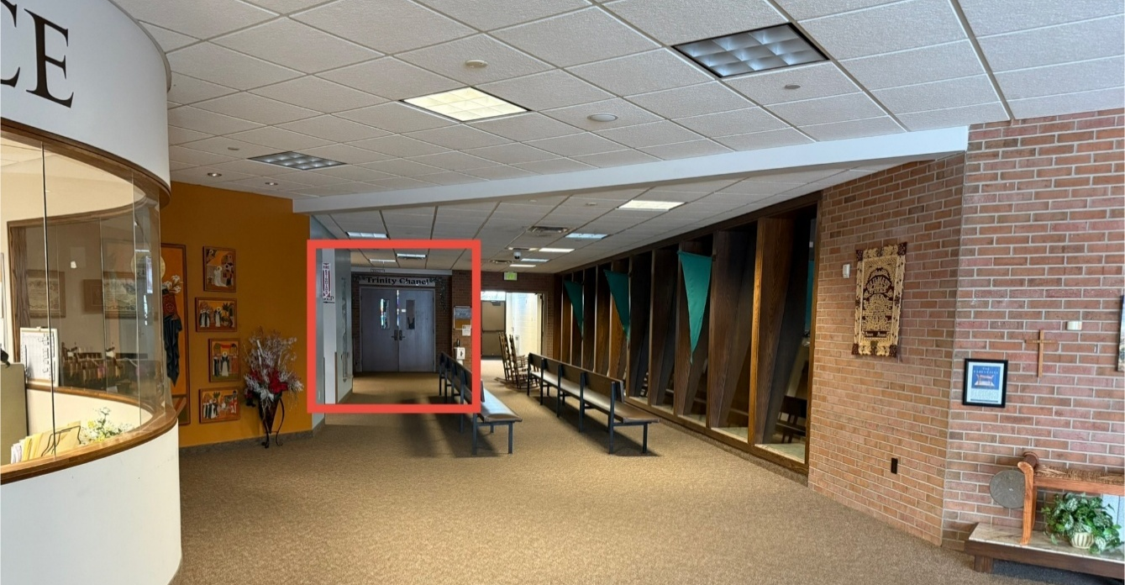

GLP: "Gerald L. Pochyla" room. It's a small conference room that you'll pass on the way to the Trinity Chapel (it will be on your left). It's a long hallway that leads to a wooden door, and you'll see a confessional in the room as well. Sometimes confessions are heard in there in addition to the chapel.
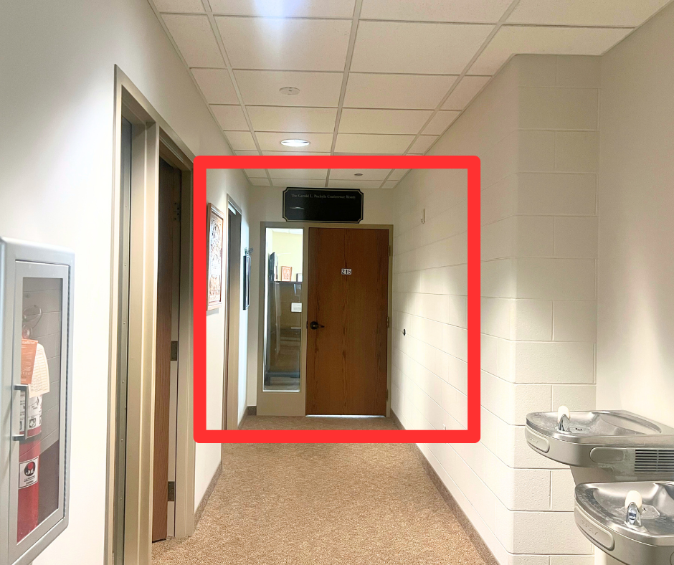

SCR: Siena Conference Room, which is a large gathering space on the lower level of the building.
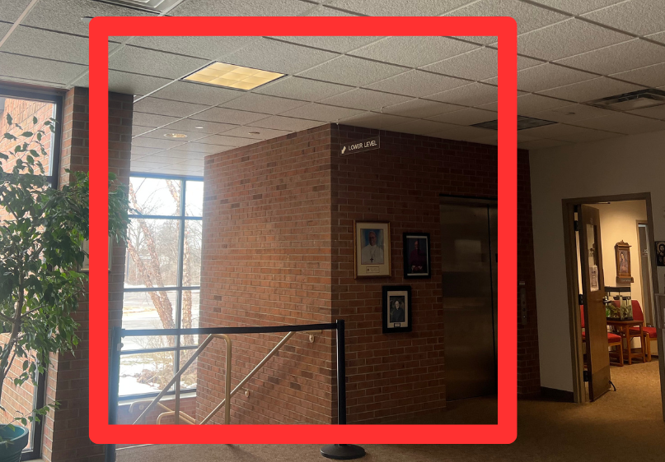
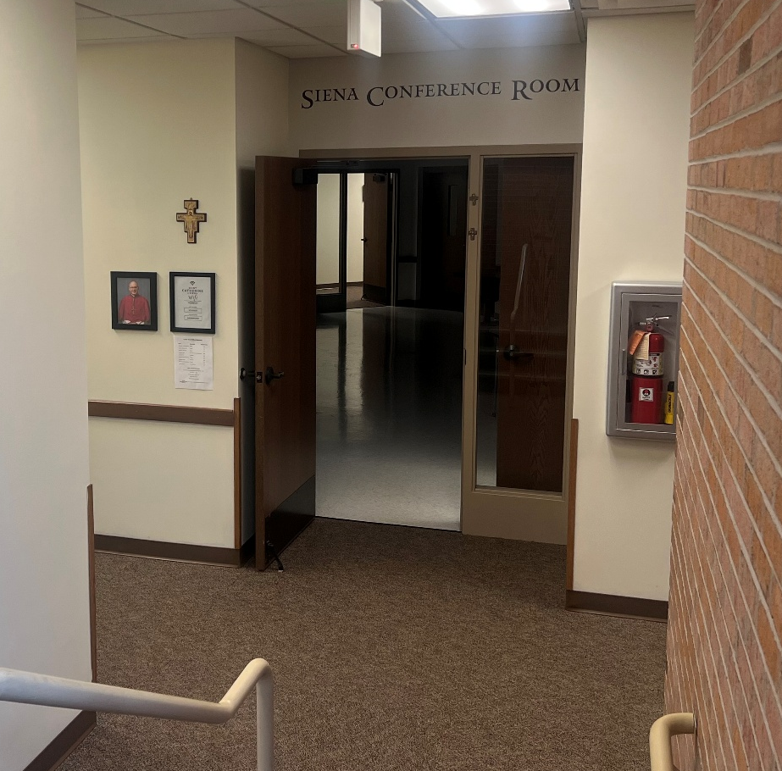

Narthex: The main space outside of the main church, when you enter the main doors.
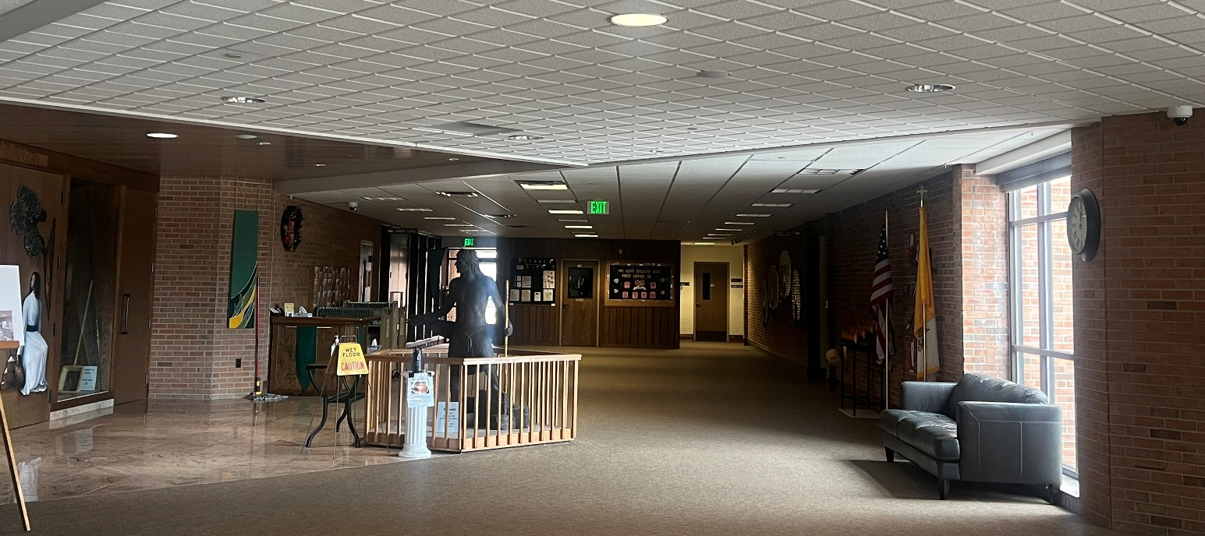
Marian Hall: The cafeteria with a kitchen connected. It’s at the end of the two classroom hallways in the main building. To get there from the main doors into the church building, you take a right until you see a hallway.
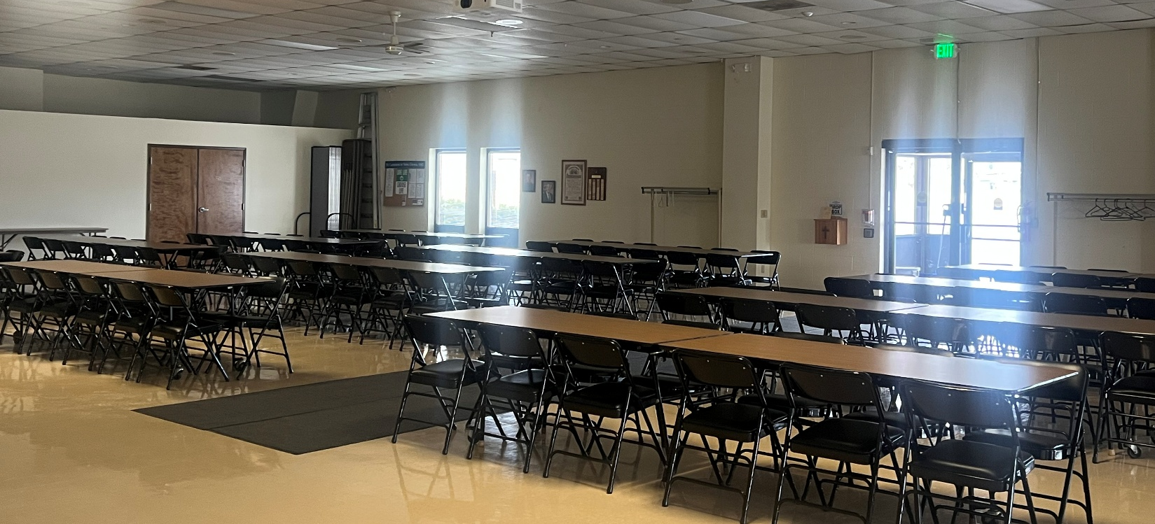
The Rectory: This is the Priest’s home, the house you see across the parking lot. It is building number 1124.
The Stanley Centre: It’s the large building in the back parking lot. It is building number 1130.
The Main Church: The first building when pulling into the parking lot and that is seen out on the road. It is building number 1150.
Classrooms 1-12: When entering in through the main building doors and taking a right (going the opposite direction of the Front Office), they’re down the first hallway to the right.
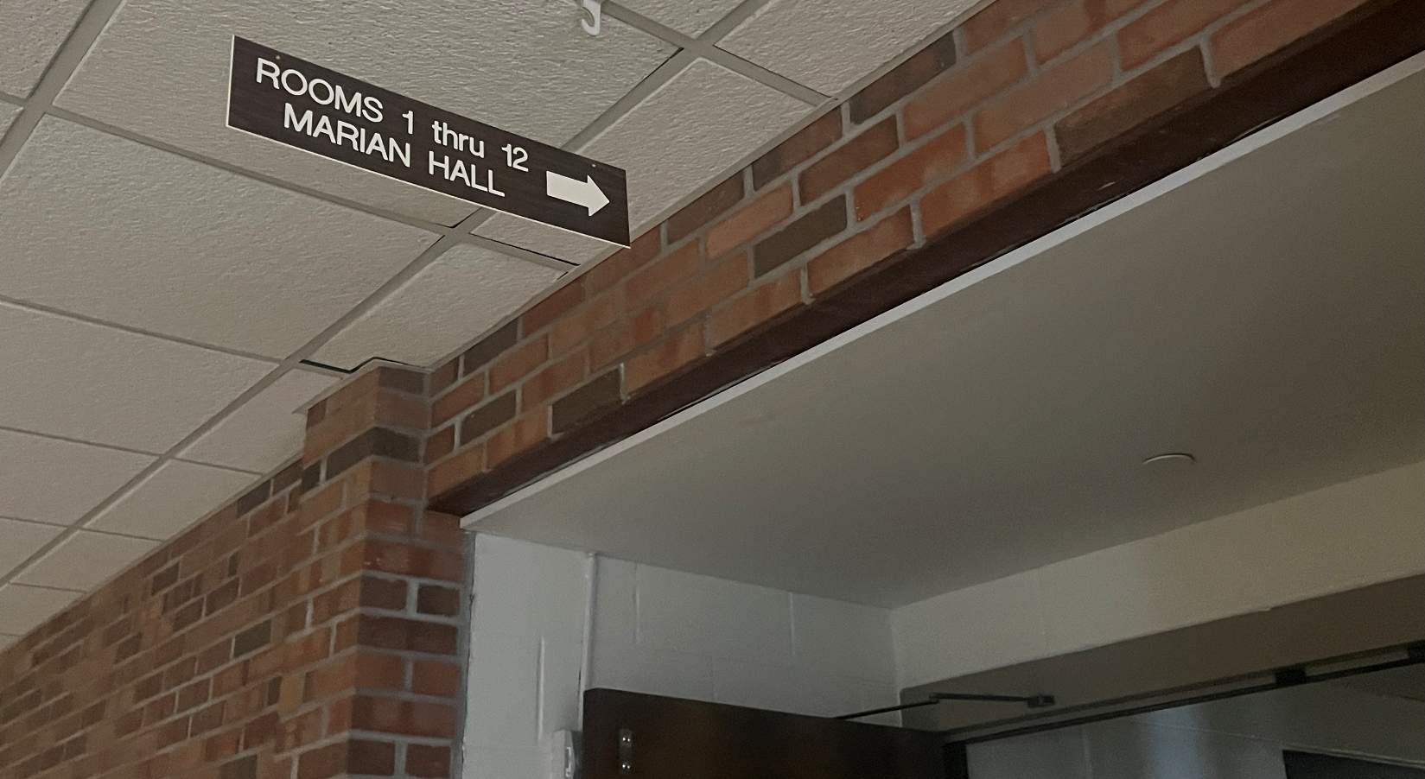
Classrooms 13-24: When entering in through the main building doors and taking a right (going the opposite direction of the Front Office), they’re down the second hallway to the right. 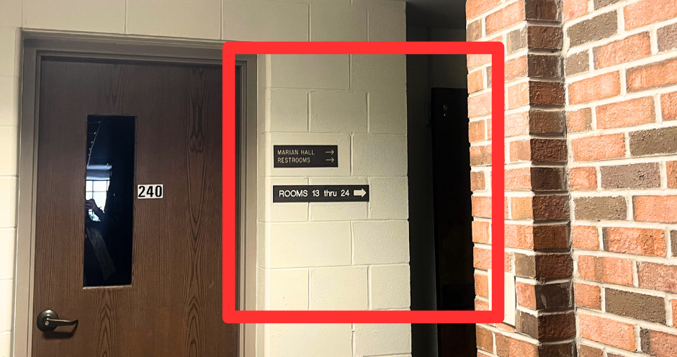
GWR: The Guadalupe Worship Room, which is a room within the Stanley Centre, next to the gym. (The Stanley Centre is across the parking lot from the church).
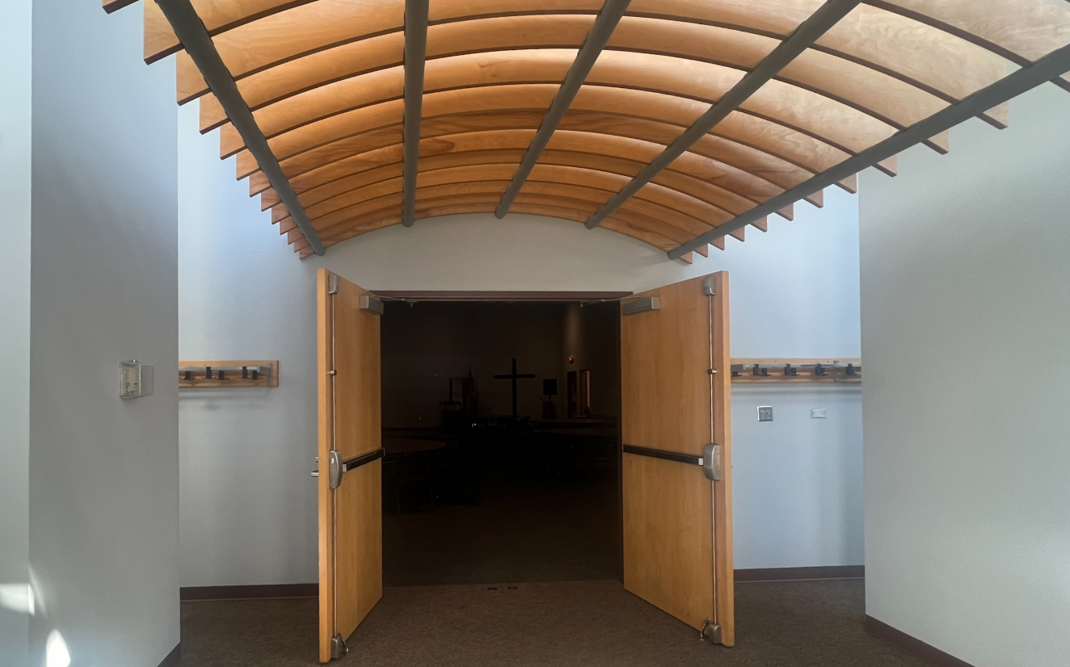
Fellowship: The Fellowship Room is room 110 within the Stanley Centre that is the first room on the right in the hallway when walking into the Stanley Centre from either of the glass doors.
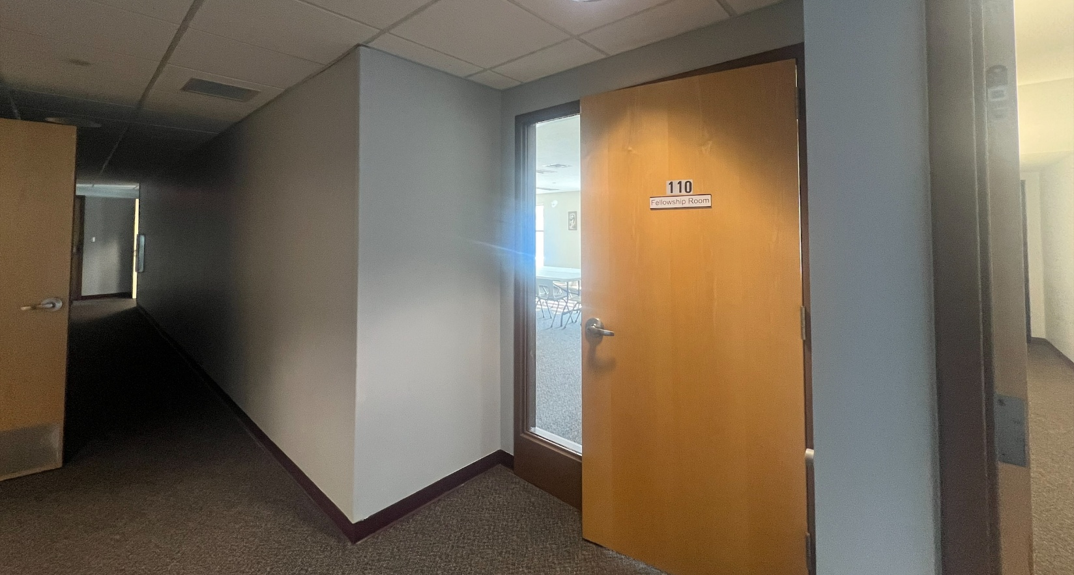
CFF: Children's Faith Formation (similar to Sunday School or Religious Education classes for our youngest parishioners)

YFF: Youth Faith Formation. Classes for our teens and young adults

OCIA: Order of Christian Initiation for Adults. This is the new abbreviation that replaces "RCIA" (Rite of Christian Initiation for Adults). This is the program that adults who are seeking to become Catholic will go through in order to receive their Catholic sacraments.

OCIC: Order of Christian Initiation for Children. This is the program that children who are seeking to become Catholic will go through in order to receive their Catholic sacraments.

SVDP: St. Vincent de Paul, a ministry we work with (that many of our parishioners are active within) that assists those in need of financial support and/or may be in need of material items. They also run the Thanksgiving Basket event every year where we deliver Thanksgiving meals to members of our community who may otherwise go without.

VIRTUS: This is the training program that anyone who works with children must go through. In order to work with children in any capacity, people must be VIRTUS-trained.

WoW: Women of the Word. A class that runs regularly throughout the year that covers different scripture studies and is women only.

KoC: Knights of Columbus. A Catholic fraternity made up of men seeking to deepen their connection with their faith and the Church, as well as provide service to those in need.

